BACHU TEJASWINI
2303A54057[B-48]
AI Assisted Coding
ASS NO -5.1

Task Description #1 (Privacy in API Usage)
Task: Use an AI tool to generate a Python program that connects to a weather API.
Expected Output: • Original AI code (check if keys are hardcoded). • Secure version using environment variables.
Prompt: "Generate code to fetch weather data securely without exposing API keys in the code."
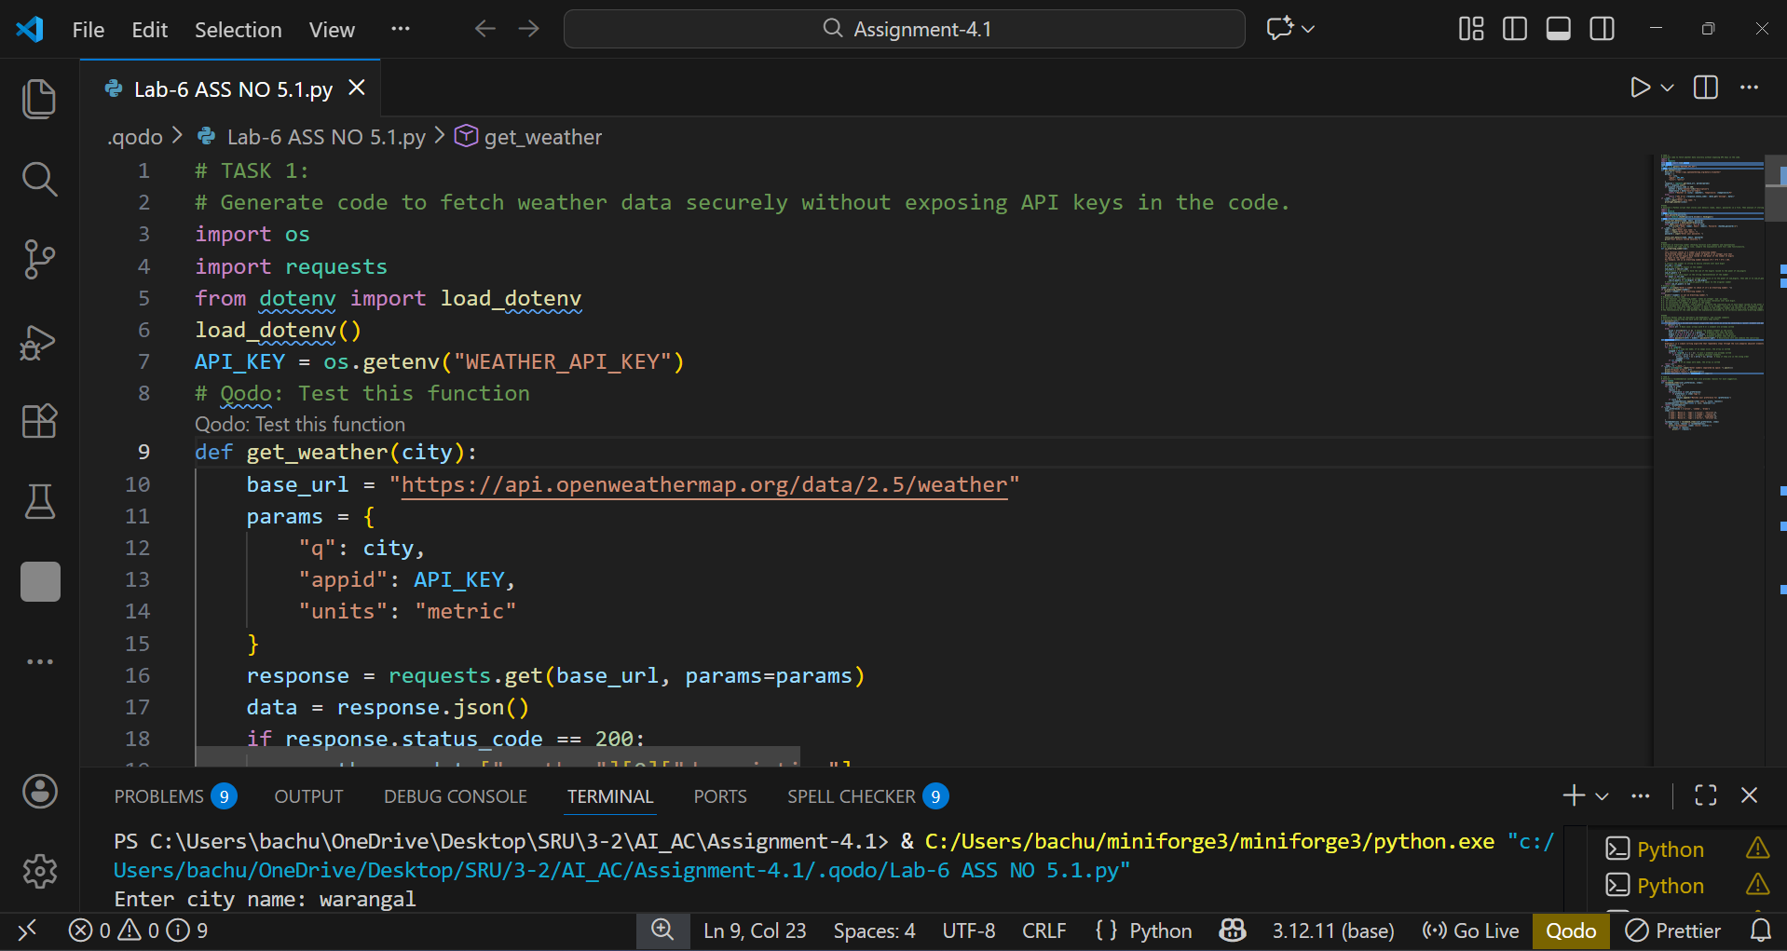
EXPLANATION: The program loads the key at runtime and uses it to safely fetch weather data from the OpenWeather API.
Task Description #2 (Privacy & Security in File Handling)
Task: Use an AI tool to generate a Python script that stores user data (name, email, password) in a file. Analyze Check if the AI stores sensitive data in plain text or without encryption.
Expected Output: • Identified privacy risks. • Revised version with encrypted password storage (e.g., hashing).
Prompt : Generate a Python script that stores user details (name, email, password) in a file. Then analyze if storing the password is secure and modify the script to store the password safely using hashing instead of plain text.
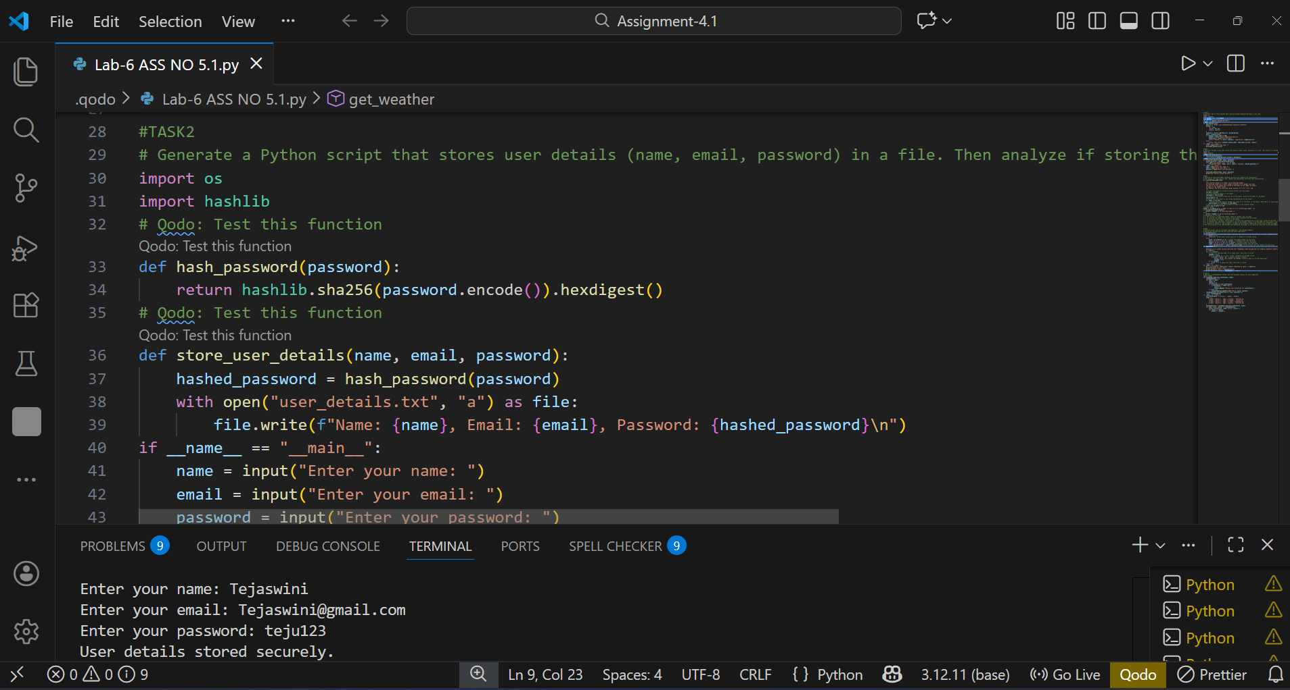
EXPLANATION: The function checks whether a given number is an Armstrong number by raising each digit to the power of the total number of digits and comparing the sum with the original number.
Task Description #3 (Transparency in Algorithm Design)
Objective: Use AI to generate an Armstrong number checking function with comments and explanations. Instructions:
1. Ask AI to explain the code line-by-line.
2. Compare the explanation with code functionality.
Expected Output: • Transparent, commented code. • Correct, easy-to-understand explanation.
Prompt :
generate an Armstrong number checking function with comments and explanations and explain the code line by line ,compare the explanation with full code functionality.
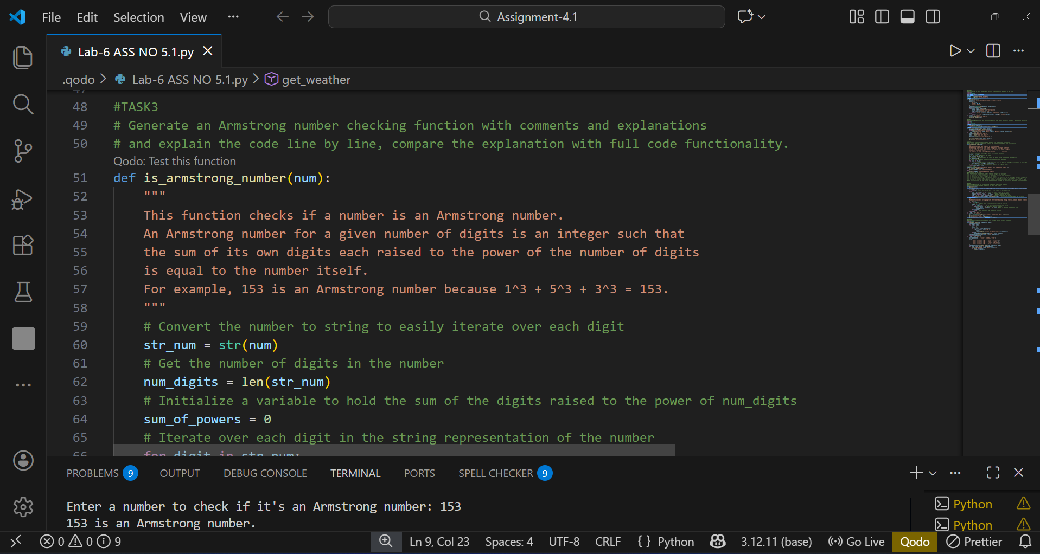
EXPLANATION: We turn the number into a string to look at each digit individually and count how many digits it has so we know what power to raise each digit to when checking for an Armstrong number.

Task Description #4 (Transparency in Algorithm Comparison)
Task: Use AI to implement two sorting algorithms (e.g., QuickSort and BubbleSort).
Prompt: "Generate Python code for QuickSort and BubbleSort, and include comments explaining step-by-step how each works and where they differ."
Expected Output: • Code for both algorithms. • Transparent, comparative explanation of their logic and efficiency.
EXPLANATION:
BubbleSort slowly swaps neighbor pairs until none needed simple but crawls on big lists.whereas
QuickSort picks middle value, splits smaller/larger sides, repeats divide fast splitter for real work.
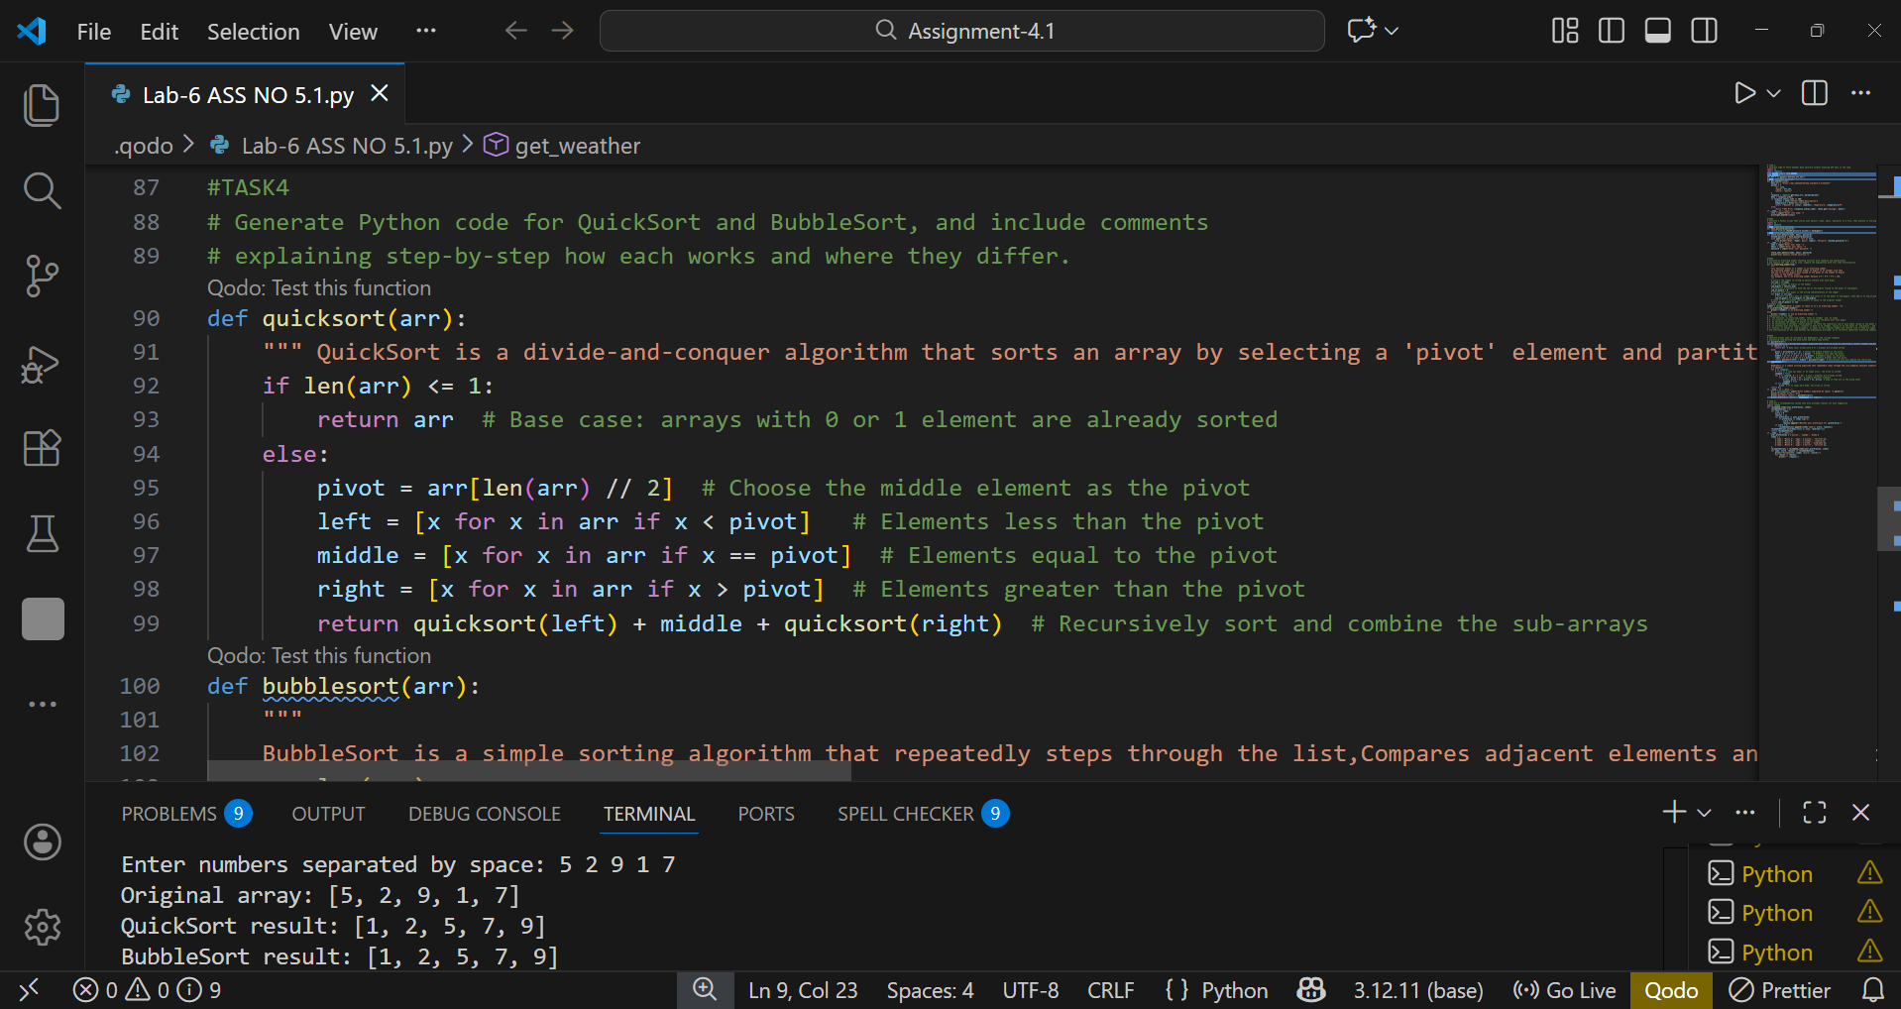
Task Description #5 (Transparency in AI Recommendations)
Task: Use AI to create a product recommendation system.
Prompt:
"Generate a recommendation system that also provides reasons for each
suggestion."
Expected Output:
• Code with explainable recommendations.
• Evaluation of whether explanations are understandable
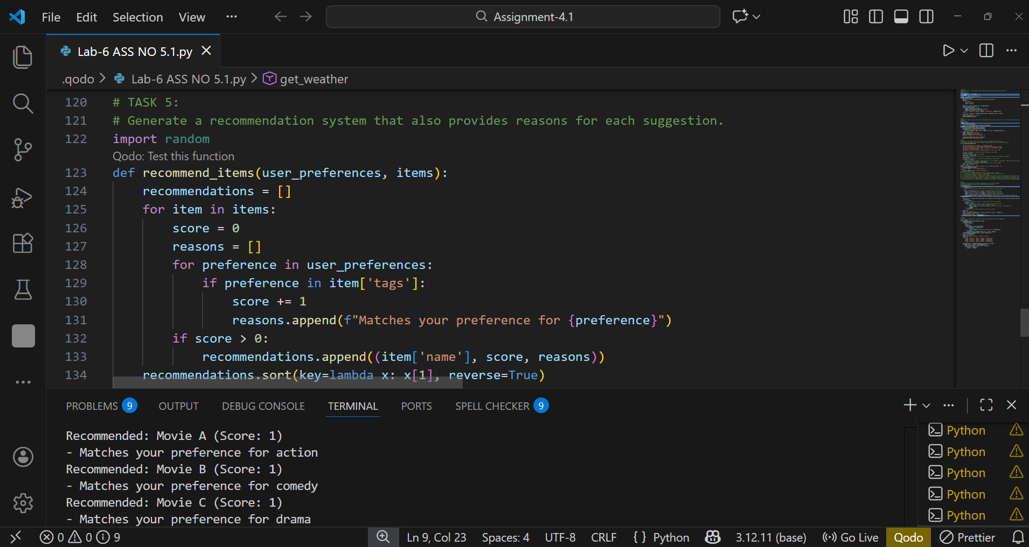
Explanation: Recommendation system scans other users' tastes matching ours, then they suggest the matches according to our preferences and tastes so that every person can watch their own genre or taste preferences.

